Research on the Arctic Oscillation: Past, Present, and Future

Hiroshi L. Tanaka
Center for Computational Sciences
University of Tsukuba
Tsukuba 305-8572 Japan

- Arctic Oscillation

The Arctic Oscillation (AO) postulated by Thompson and Wallace (1998; 2000) has attracted more attention in recent years. The AO is a north-south seesaw of the atmospheric mass between the Arctic region poleward of 60°N and a surrounding zonal ring in the mid-latitudes. It is defined as a primary mode of an empirical orthogonal function (EOF) for the sea-level pressure field in the Northern Hemisphere. The spatial pattern of the AO is characterized by its zonally symmetric or “annular” structure centered in the Arctic.
The AO bears a superficial resemblance to the leading mode of low-frequency variability in the Southern Hemisphere, which is now referred to as a Southern Hemisphere annular mode (SAM). In this regard, a terminology of Northern Hemisphere annular mode (NAM) is preferred for the AO by Wallace (2000). We will refer to the AO as the EOF-1 of atmospheric variability with one sign over the Arctic and two poles of opposite sign over the Pacific and Atlantic sectors, while the terminology of the annular mode is reserved essentially for the zonally symmetric variation in the atmosphere.

- Past Study

The zonally symmetric features of the AO may be found in the historical literature of the general circulation study tracing back to Exner (1925) as illustrated in Fig. 1, where one point correlation map centered at the North Pole is presented over the Northern Hemisphere. The correlation is positive over the Arctic and the zero line is located along the latitudinal line near 50°N. He found that the correlation is negative in mid-latitudes with a distinct center over Europe. The correlation pattern may be identified as the North Atlantic Oscillation (NAO) in present days, although the center of action is slightly shifted.
The similar north-south see-saw of the surface pressure pattern was analyzed by Walker and Bliss (1932) and by C. G. Rossby (1939). Rosby noted that the longitude of the Aleutian Low was highly correlated with the mean pressure difference between 35°N and 55°N (i.e., the strength of the zonal wind along 45°N) during the winter of 1938-39. The low index state (weak zonal flow along 45°N) was defined by an extensive polar vortex and pronounced baroclinicity at mid-latitudes, and the high index state by a contracted polar vortex and pronounced baroclinicity at high latitudes.
The concept of the zonal index and the index cycle was introduced by Namias (1950), who proposed that the leading mode of variability in the zonal mean circulation was, in fact, characterized by meridional shifts in the strength of the zonal flow between 35°N and 55°N. The index cycle was extensively analyzed to show a dominant period of about 4 weeks, but the statistical significance appeared to fail the proof of the existence.
It may be important to note that the classic zonal index by Namias is a measure of the strength of the subtropical jet, while the AO index by Thompson and Wallace is a measure for the polar jet; the former measures the intensity of baroclinicity which excites the baroclinic eddies in synoptic scale, whereas the latter is the result of the accumulated westerly momentum by the baroclinic eddies. The AO fluctuations dominate over the weekly and longer time scale, but the time spectrum is quite red up to 4-month period which shifts to white noise spectrum beyond that. There is a noticeable signal at the decadal to longer time scale associated with the global warming (e.g., Shindell et al. 1999; Fyfe et al. 1999; Tanaka 2003).

- Present Study

The AO is successfully simulated by a number of realistic general circulation models with fixed forcing (Feldstein and Lee 1998; Yamazaki and Shinya 1999; Fyfe et al. 1999; Shindell et al. 1999; Limpasuvan and Hartmann 1999, 2000; Boer et al. 2001; Robertson 2001). The basic features of the zonally symmetric structures are also

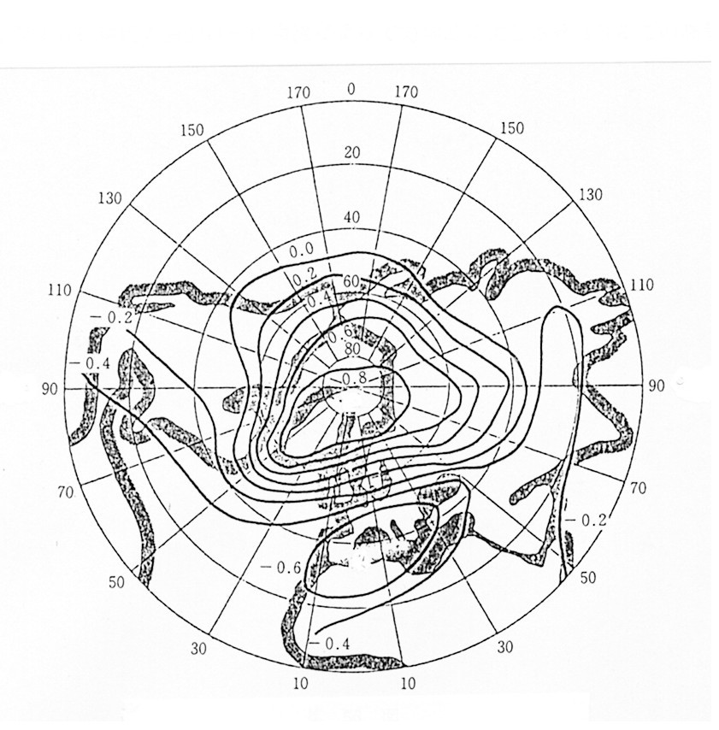
Figure1. One point correlation map of the surface pressure centered at the North Pole. The prototype of NAO is analyzed in the map (After Exner 1925).

simulated using simple quasi-geostrophic and primitive equation models with simple physics and no topography or seasonal cycle (Robinson 1991; 1994; 1996; James and James 1992; Yu and Hartmann 1993; Lee and Feldstein 1996; Feldstein and Lee 1998; Akahori and Yoden 1997). Because the external forcing of the model is independent of time, the variability found in these simple models is the unforced variability associated with dynamical processes internal to the atmosphere (Feldstein 2002). The dynamical examination of the annular modes shows that the baroclinic eddies in mid-latitudes play an important role for the internal variability of the zonal mean flow through the positive feedback in momentum budget between the eddies and the mean flow (Karoly 1990; Shiotani 1990; Hartmann 1995; Kidson and Sinclair 1995; Hartmann and Lo 1998; Yamazaki and Shinya 1999; Lorenz and Hartmann 2001; Tanaka and Tokinaga 2002).

It is generally agreed that the AO is essentially a mode internal to the atmosphere. However, the realization as to whether the AO is a physical normal mode of a linearized dynamical system or a simple statistical illusion of independent multiple teleconnections is an open question under the active debate, and no general consensus has yet been reached (Wallace and Gutzlar, 1981; Wallace 2000; Deser 2000; Ambaum et al. 2001; Itoh 2002; Wallace and Thompson 2002).

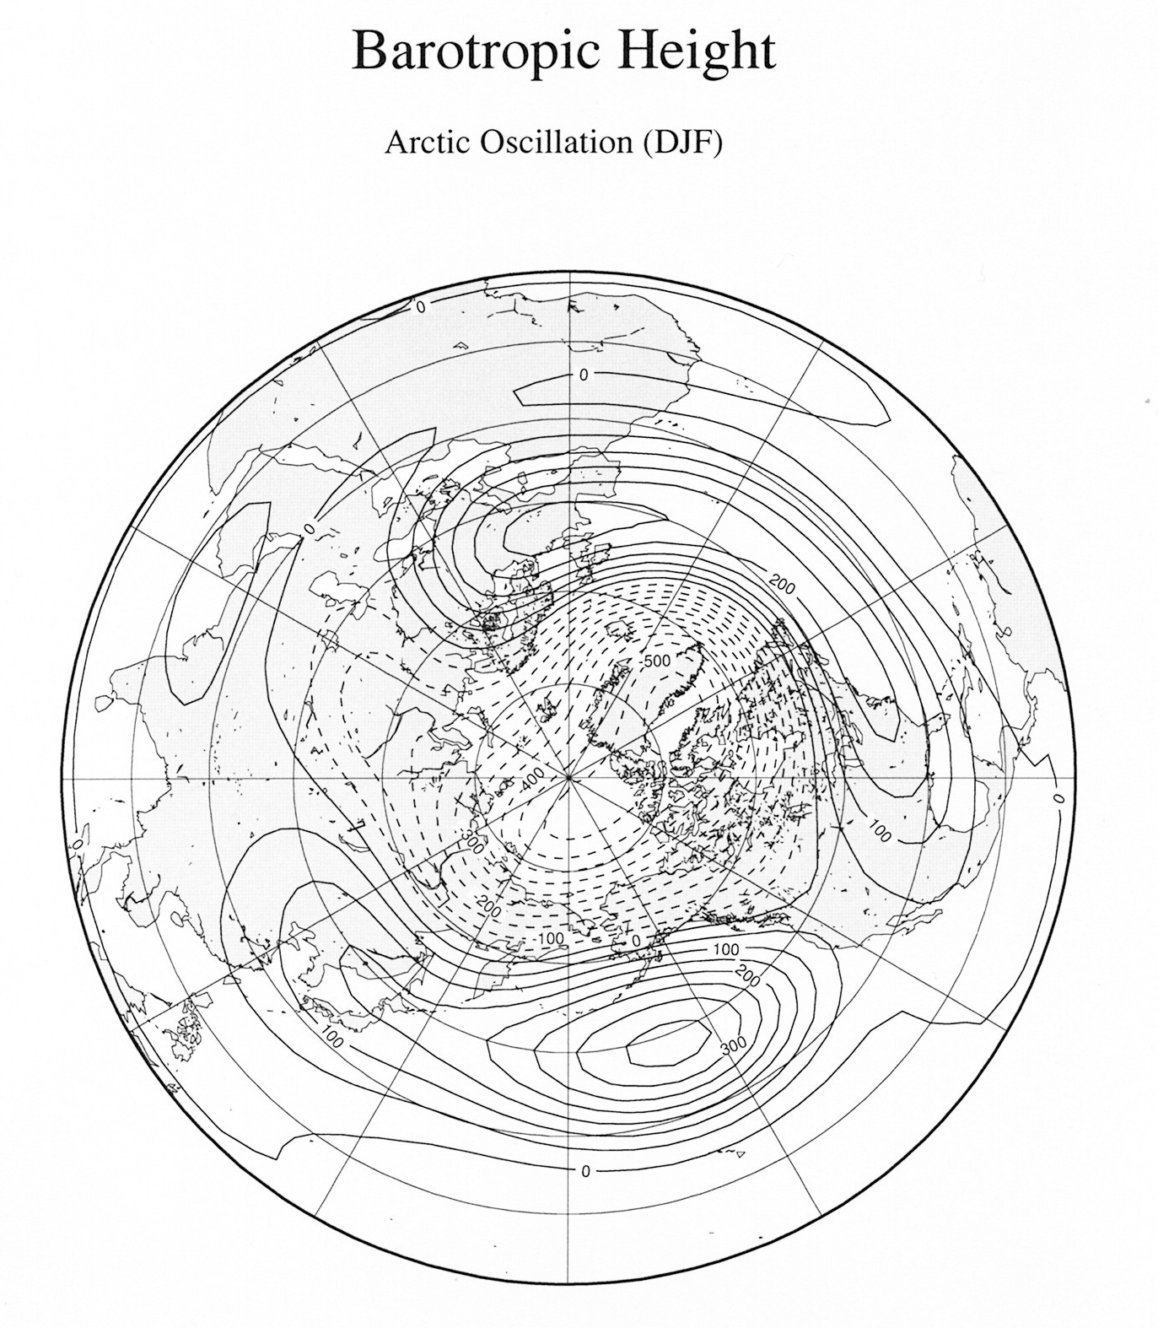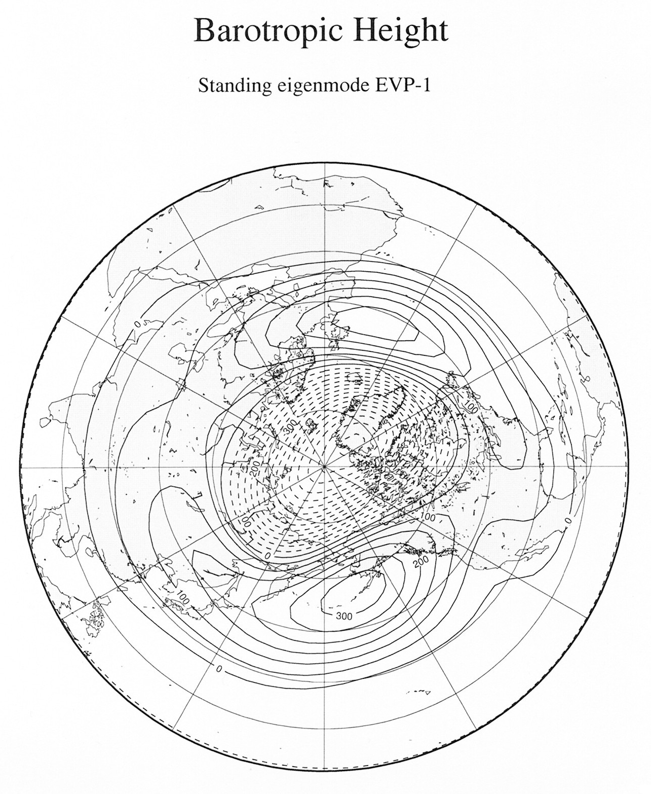

Figure 2. Arctic Oscillation analyzed for the barotropic component of the observed atmosphere (left) and the structure of the singular eigenmode of the atmosphere (right) (After Tanaka and Matsueda 2005).

Concerning the controversial argument, Tanaka and Matsueda (2005) provided a comprehensive evidence that the AO is a dynamical normal mode of the general circulation of the atmosphere (see Fig. 2). In their study the eigenmodes and singular modes were analyzed for a linearized dynamical system of the global atmosphere. Since the AO is defined by the fluctuation in the sea-level pressure, which is equivalent to the fluctuation in the barotropic component of the atmosphere, the AO is investigated in the framework of the shallow water system derived from the 3D normal mode decomposition. The neutral mode theory proposed by Kimoto et al (2001) and the singular eigenmode theory were compared using the barotropic model, which has demonstrated the capability of simulating the realistic AO in the nonlinear framework. It was concluded that the singular eigenmode of the dynamical system emerges resonantly as the AO in response to the arbitrary steady forcing (Tanaka and Matsueda in this volume).

- Future Study

Recently, Yukimoto (2005) conducted ensemble model experiments of the 20th Century climate for 151 years from 1850 to 2000 (called 20C3M) using the MRI-CGCM2.3 (Meteorological Research Institute, Japan, coupled GCM version 2.3) under the IPCC 4th Assessment Report Project. As expected, the most dominant mode of the variation in the Northern Hemisphere was the AO in the individual model atmosphere. The long term trend of the ensemble mean experiments in response to the external forcing of the increased greenhouse gases exhibits the characteristic pattern of the AO as consistent with the observational analysis (Shindell et al. 2001). Interestingly, the internal variability of each ensemble member subtracting the ensemble mean trend appears again to show the same pattern of the AO. According to the result, both of the external forcing and the internal variability result in the common atmospheric response represented by the AO. The result strongly supports the theory of the singular eigenmode as the interpretation of the AO excited by various forms of forcing.
If this is the case, we can readily predict that the dominant atmospheric response to the global warming in 21st Century would occur in the pattern of the AO. This projection is the future subject to be investigated more in the next decade for the research of the AO.

Reference:

Exner, F.M., 1925: Dynamische Meteorologie. Wien, Verlag Von Julius Springer.
Tanaka, H.L., 2003: Analysis and modeling the Arctic Oscillation using a simple barotropic model with baroclinic eddy forcing, J. Atmos. Sci., 60, 1359-1379.
Tanaka, H.L. and M. Matsueda, 2005: Arctic Oscillation analyzed as a singular eigenmode of the global atmosphere. J. Meteor. Soc. Japan, 83, 611-619.
Yukimoto, S., 2005: Decadal variability similar to the AO in the 20th Century experiments simulated by the MRI-CGCM2. Gross Wetter, 43, 84-92.
Refer to Tanaka (2003) and Tanaka and Matsueda (2003) for the rest of the references.

